ASSIGNMENT 3

CSA0593

-192324289

RAKINA S

QUESTION:

Hospital Management System Database with Patient Care Managemen

t -Design tables for patients, doctors, appointments, medical records, and billing.

- Implement stored procedures for patient registration, appointment scheduling, and billing.

- Develop SQL queries for reporting patient medical history, doctor schedules, and billing summaries.

- Test using various failure scenarios

ANSWER:

A Hospital Management System Database with Patient Care Management is designed to efficiently manage patient information, medical records, and treatment plans. The database consists of multiple tables, including Patients, Doctors, Nurses, Appointments, Medications, Lab Tests, and Medical Records. The Patients table stores demographic information, medical history, and contact details. The Doctors and Nurses tables store information about healthcare professionals, including their specialties, qualifications, and schedules.

The Appointments table manages scheduling and booking of appointments, while the Medications table tracks prescriptions, dosages, and administration schedules. The Lab Tests table stores results of laboratory tests and diagnostic procedures. The Medical Records table stores comprehensive medical histories, including diagnoses, treatments, and outcomes. Relationships between tables are established using foreign keys, enabling efficient data retrieval and updating.

To ensure data security and integrity, the database can be designed with role-based access control, data encryption, and regular backups. By implementing a Hospital Management System Database with Patient Care Management, healthcare providers can improve patient care, streamline clinical workflows, and enhance operational efficiency.

FLOWCHART:

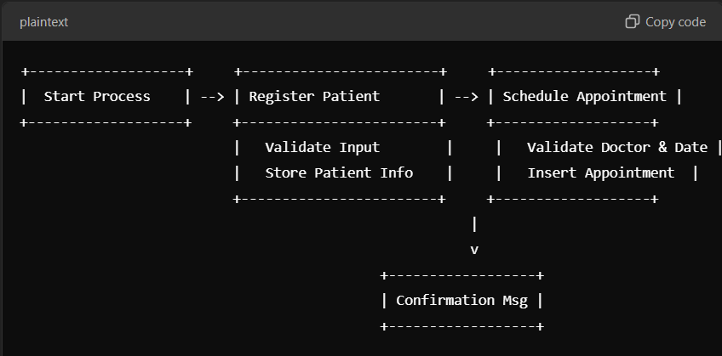

1.PATIENT TABLE:

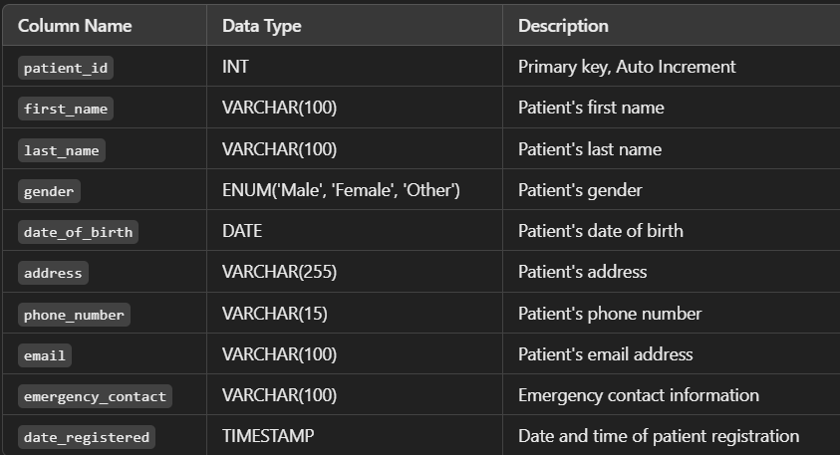

2.DOCTORS TABLE

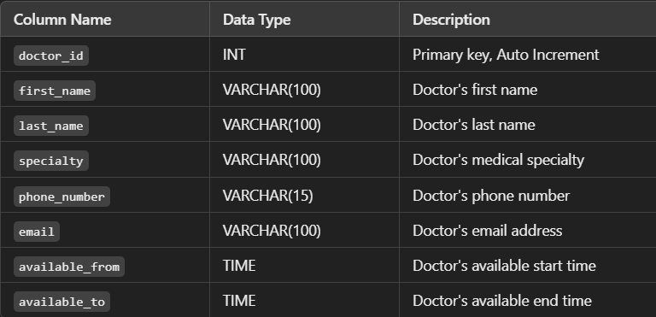

3.APPOINTMENTS TABLE

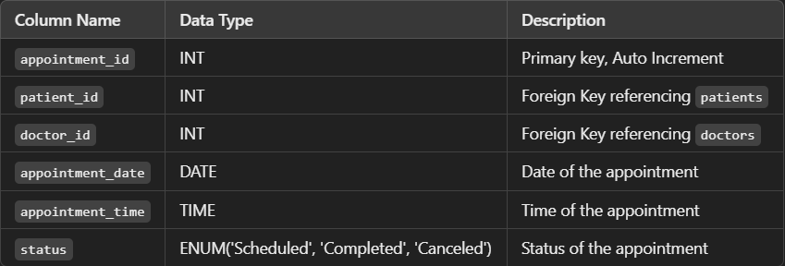

4.MEDICAL RECORDS:

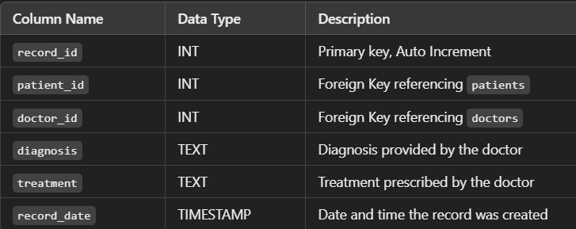

4.BILLING:

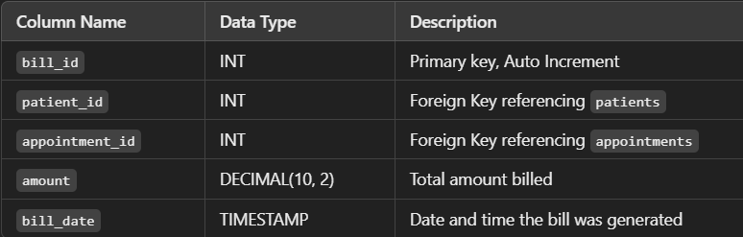

Stored Procedures:

Patient Registration

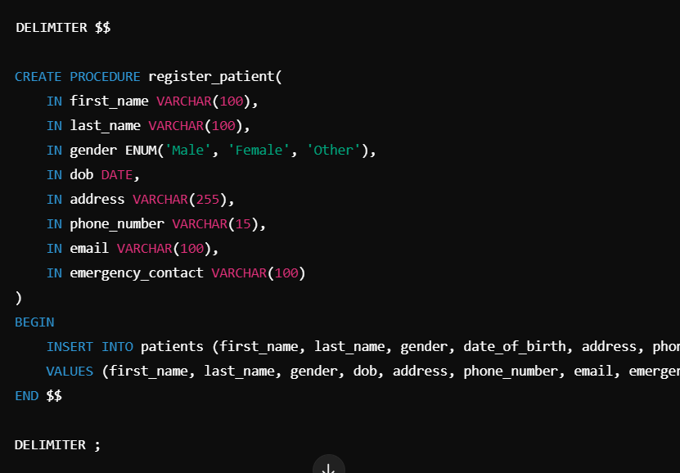

APPOINTMENT SHEDULING:

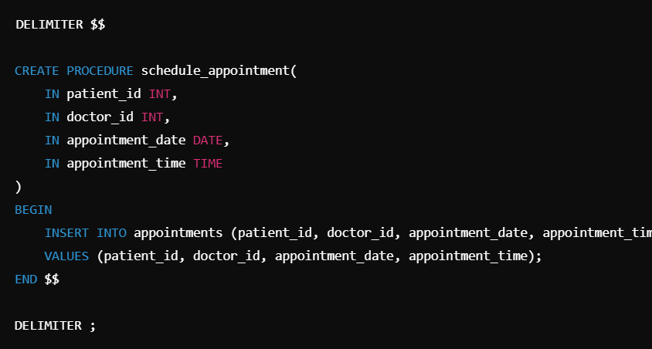

BILLING:

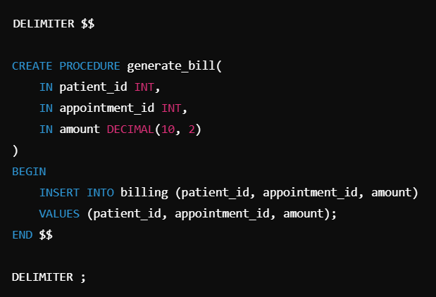

SQL Queries for Reporting:

Patient's Medical History

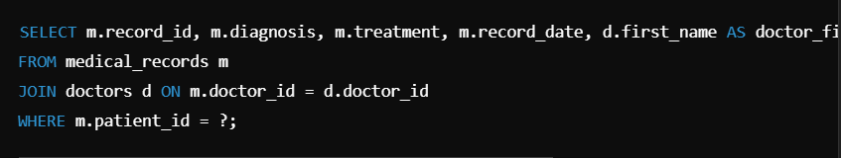

Doctor's Schedule

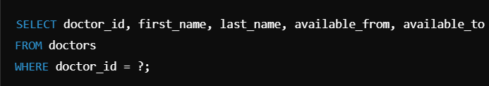

Billing Summary for a Patient

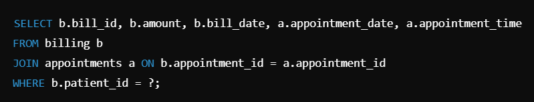

Testing Failure Scenarios:

